**Healthy Snacks ICE**

A snacks manufacturer has several products in its portfolio, some healthy and some not so healthy. Being a socially conscious company, it wants to increase the sales of its healthy snacks. After doing a detailed literature review and qualitative research, it identifies the following variables that would likely influence tendency to buy a healthy snack: taste claims vs. health claims; fear appeals vs. factual appeals and a personality variable, health consciousness of a person. They conducted a couple of experiments to see which type of appeal worked and for which type of person. In experiment 1, they varied taste claims vs. health claims and in experiment 2, they varied fear vs. factual appeals. In both they measured health consciousness with standard scales and obtained high cronbach alphas. The key issues that confront them are:

1. Do taste claims work better or health claims? Does the effectiveness of type of claim depend on health consciousness? The data to answer these questions are in “tastevshealth.sav”.
2. Do fear appeals work better or do factual appeals? And does type of appeal interact with health consciousness? The data to answer these questions are in “fearvsfactual.sav”.

The dependent variables for both the above questions are credibility and purchase intention. The covariates are the demographic variables.

The experimental stimuli are presented in appendix A. Can you help them analyse the data? What would your recommendations be for them?

**Appendix A: Experimental Stimuli**

**Taste Claim**

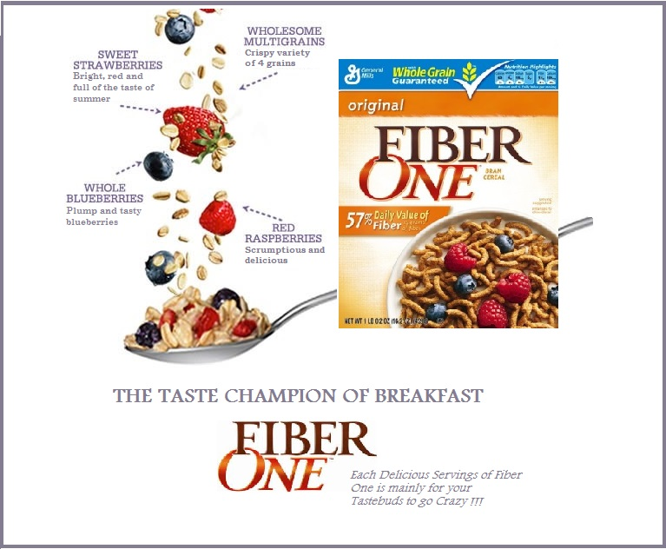

**Health Claim**

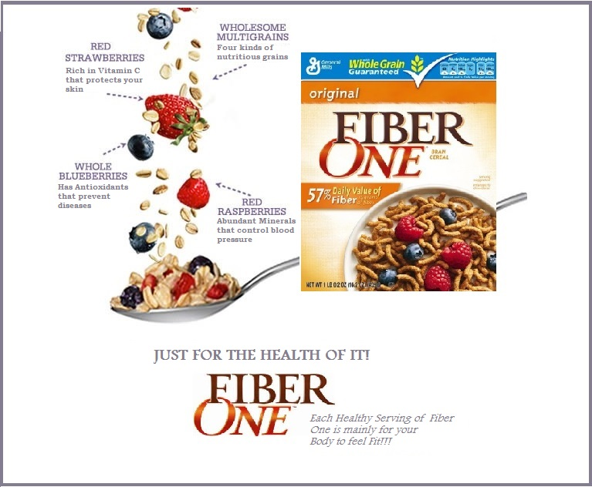

**Fear Appeal**

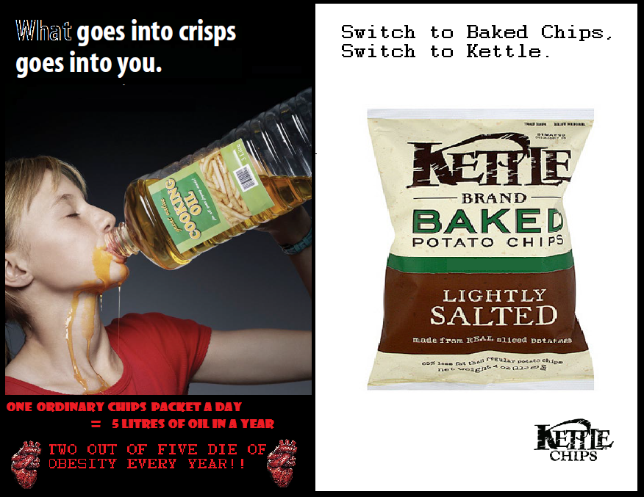

**Factual Appeal**

